# React

# ReactJS-HOL

# Mandatory HandsOn

Create a React Application named “officespacerentalapp” which uses React JSX to create elements, attributes and renders DOM to display the page.

**npx create-react-app officespacerentalapp**

**cd officespacerentalapp**

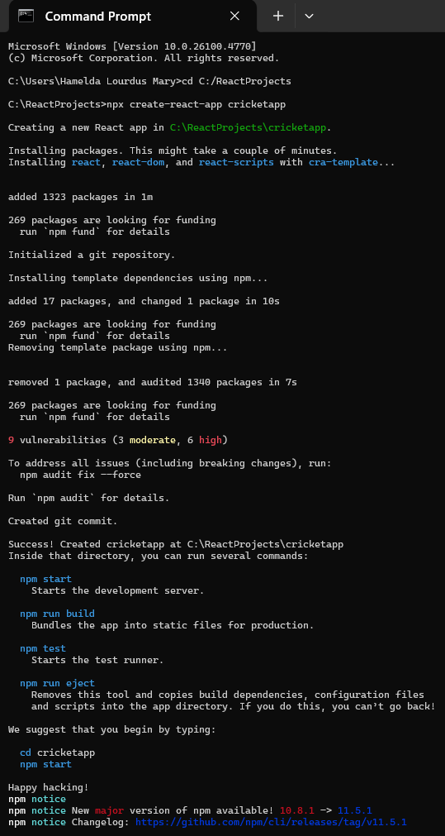

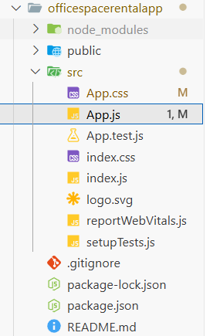

**App.js**

import './App.css';

function App() {

  const element = "Office Space";

  const ItemNames = [

    {

      Name: "DBS",

      Rent: 50000,

      Address: "Chennai",

      image: "https://media.istockphoto.com/id/1460755337/photo/white-color-theme-modern-style-office-with-exposed-concrete-floor-and-a-lot-of-plant-3d.jpg?s=612x612&w=0&k=20&c=PX1TFWVrLL34jgkmFREmxrzy3M4rqhBk4NMrHFOTmo8="

    },

    {

      Name: "Cognizant",

      Rent: 75000,

      Address: "Bangalore",

      image: "https://encrypted-tbn0.gstatic.com/images?q=tbn:ANd9GcR3sKBOG8b3s2b0zxhWQX-fivRpv8Ln6pGGIQ&s"

    },

    {

      Name: "CTS",

      Rent: 55000,

      Address: "Chennai",

      image: "https://encrypted-tbn0.gstatic.com/images?q=tbn:ANd9GcQ-qBF1wiHz3p1gMUT3OuvWZh0EzbIsynNHDNwUIL7QllB6LYupx6MZwkVkwK2fWDECM4s&usqp=CAU"

    }

  ];

  return (

    <div className="App-container">

      <h1>{element} , at Affordable Range</h1>

      {ItemNames.map((ItemName, index) => {

        let colors = [];

        if (ItemName.Rent <= 60000) {

          colors.push('textRed');

        } else {

          colors.push('textGreen');

        }

        const jsxatt = (

          <img

            src={ItemName.image}

            width="25%"

            height="25%"

            alt="Office Space"

          />

        );

        return (

          <div style={{ marginBottom: '40px' }}>

          {jsxatt}

{/* Inline styling is used */}

             <h3 style={{ color: ItemName.Rent <= 60000 ? 'red' : 'green' }}>

            Rent: Rs. {ItemName.Rent}</h3>

            <h3>Address: {ItemName.Address}</h3>

          </div>

        );

      })}

    </div>

  );

}

export default App;

**Output:**

npm start

